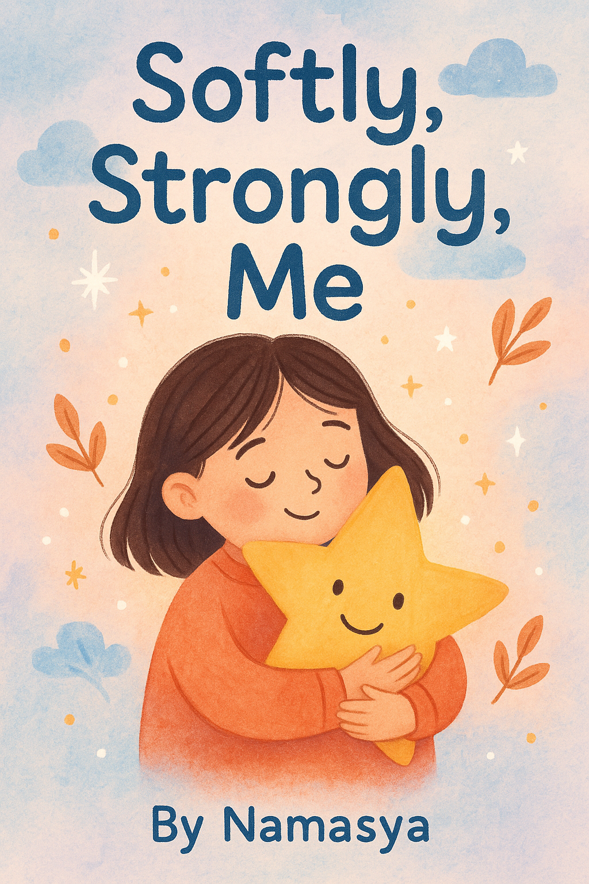

Dedication
To every child who has felt invisible, afraid to speak, or different—You are brave, powerful, and worthy of being heard.
This book is for you.

Preface
My name is Namasya, and I wrote this story because I understand what it’s like to be really quiet in a world that feels loud. I’m 13 years old now, but not long ago, I battled something called Selective Mutism (SM)—a condition that made it feel nearly impossible to speak in certain situations, even when I wanted to. It wasn’t just shyness; it felt like a storm of anxiety swirling inside me, holding my words back.
But here’s the thing: that storm can pass. Through my own journey, I worked with a therapist who helped me discover tools and strategies to manage my anxiety and find my voice. I wasn’t alone—my teachers and parents were part of that journey, too. Together, they formed a team that supported me every step of the way.
This story is inspired by those therapy sessions and the techniques I learned along the way, which I now share in the form of a story to help children who are facing the same struggles.
With the right support, encouragement, and self-belief, it’s possible to find your voice—even if it starts off quietly. This book is for all the kids who are learning to be brave in their own way and need a little reminder that they are not alone.
Happy reading!

Introduction
Have you ever felt too nervous to speak up in class or other social settings ? Or maybe you’ve hesitated to say “hi” to someone new because your voice just wouldn’t come out? You’re not alone. For many of us, anxiety can make our voices feel small, and that’s perfectly okay.
This is the story of a young girl named Iris, who has a special companion named Allegra—a gentle guide who helps her find courage and strength when her fears try to take over. Together, Iris and Allegra learn how to overcome worries by using simple tools like affirmations and breathing exercises, discovering that even the quietest voices can grow loud and proud.
Join them on their journey of bravery, self-acceptance, and joy, and see how even the most anxious moments can turn into powerful steps toward confidence.

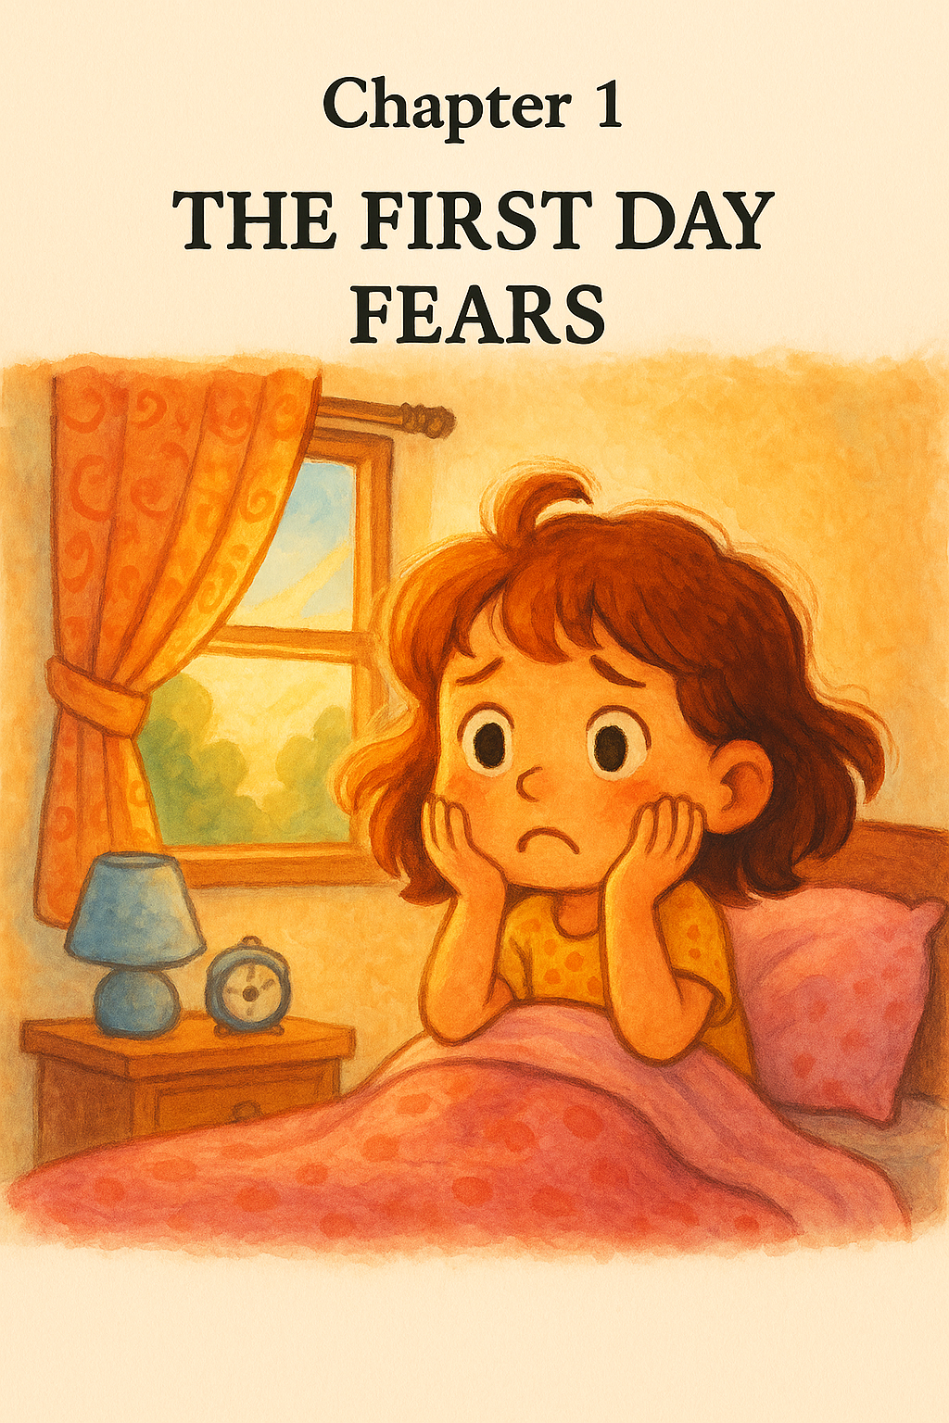
It was the first day of school!
Iris woke up with a big yawn and rubbed her sleepy eyes.
Sunlight peeked through her window, painting her room with a warm, golden glow.
Iris smiled. What a pretty day!
But then—wait a second...
Her eyes flew open. Her smile vanished.
It was the first day of first grade!
Iris’s stomach did a little flip.
Her heart beat faster.
Uh-oh! She hadn’t even gotten ready!
What if all her friends were in different classes?
What if she couldn’t make any new friends?
What if the teachers didn’t understand her?
Or worse... what if she couldn’t speak at all?!
Iris sat on the edge of her bed, holding her breath.
Her pretty morning suddenly felt not-so-pretty at all.

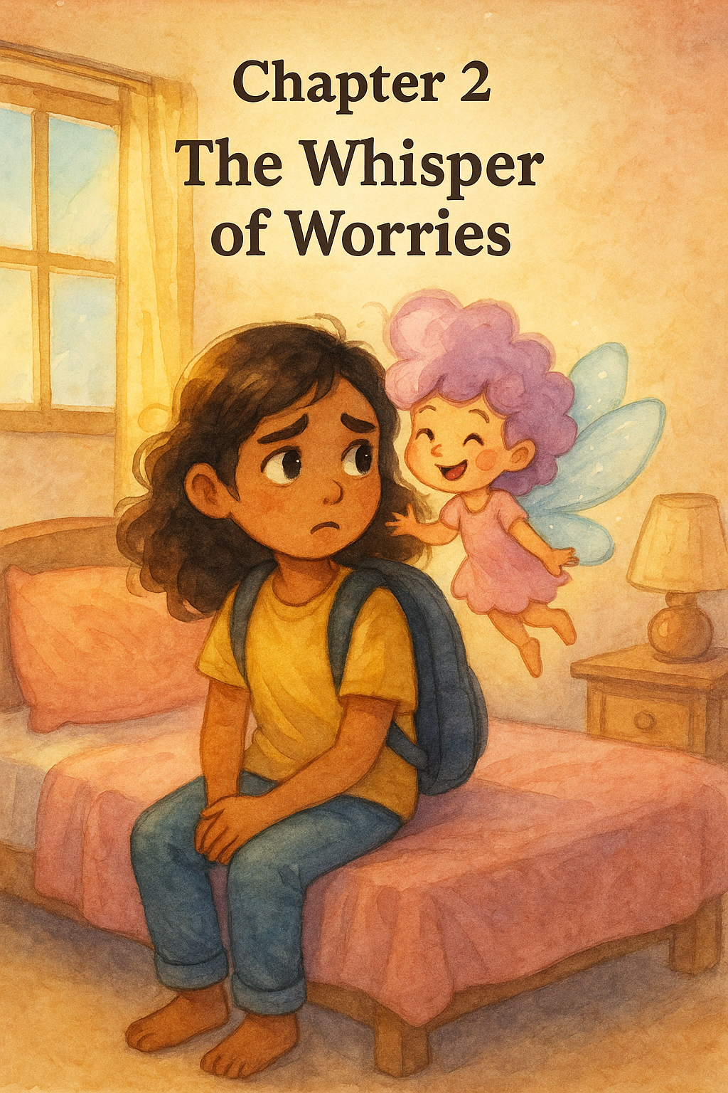
Iris sat alone, her backpack still on, her thoughts spinning like a merry-go-round.
What if I mess everything up?
What if no one likes me?
What if I say the wrong thing again?
Her chest felt tight. Her eyes stung a little.
Just then, a gentle voice tickled her ear.
“Why are you having so many bad thoughts?”
Iris turned her head fast—too fast!—and blinked.
It was Allegra—her tiny, winged sidekick with hair like cotton candy and a heart full of sunshine. She always appeared when Iris needed her the most.
“I—I don’t know,” Iris mumbled. “I just feel… small.”
Allegra fluttered onto Iris’s shoulder and gave her a big smile—the kind that warms you up from the inside out.
“It’s okay to feel small sometimes,” Allegra said softly. “But remember: confidence means knowing you are enough, just as you are. And even if you don’t feel confident right now, we can work on it together.”
Iris sniffled. “But how?”
“With a little magic,” Allegra winked. “And something called positive affirmations.”
“Affirma-what?” Iris asked, wrinkling her nose.
“Affirmations! They’re like kind spells you say to yourself. Words that remind your heart how strong it really is.”
Allegra cleared her throat and stood tall on Iris’s shoulder.
“Repeat after me,” she said with a twirl.
“I am unique.
I love myself.
I have a strong and powerful voice.
I am brave.
I matter.
I am a good person.
I accept myself, and others accept me too.
I am my own person, and I deserve to be seen.”
Iris whispered the words, then said them again—louder this time.
And just like that… the merry-go-round slowed down.
“I think this worked,” she beamed. “I really do feel better.”
Allegra winked. “That’s because the bravest magic always starts inside of you.”

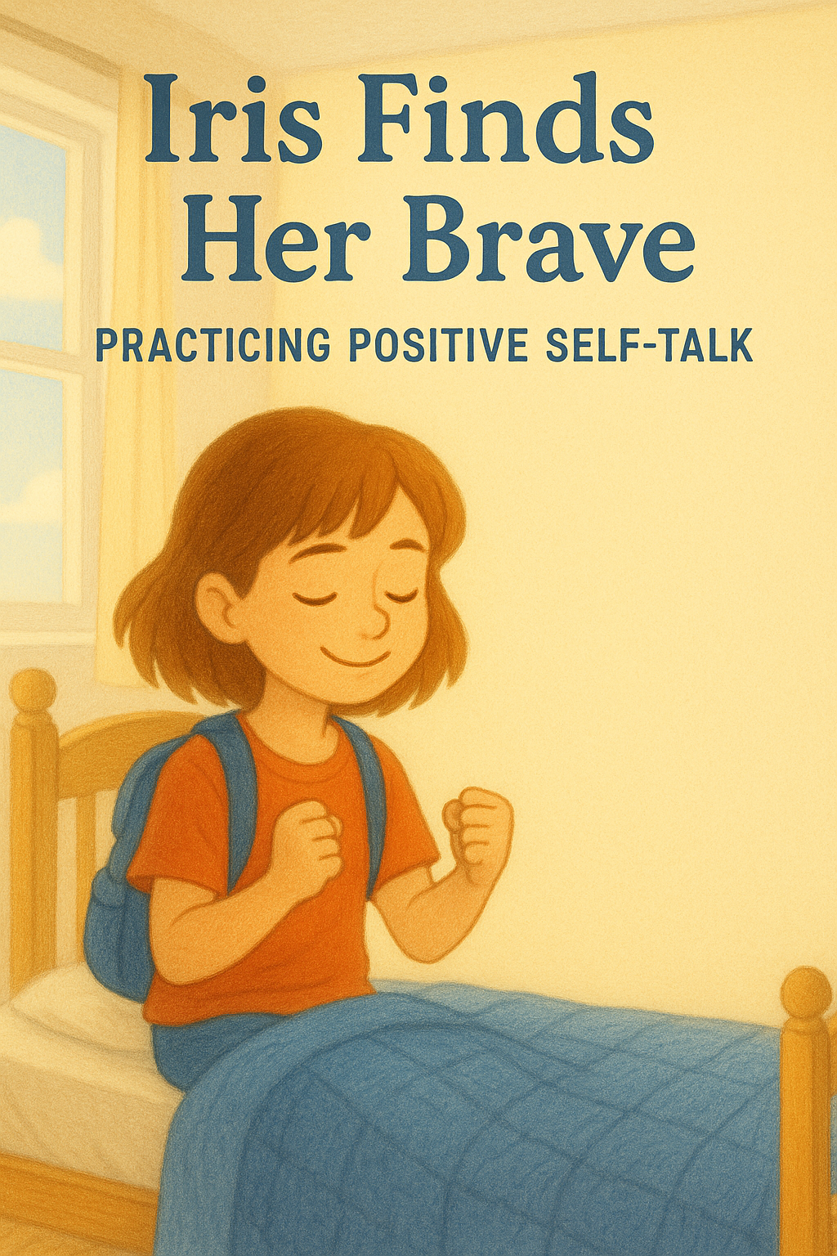
Iris sat on her bed, her fingers twisting the edge of her blanket. She looked up at Allegra, her shimmering, starry friend who always knew just what to say.
"Allegra," Iris whispered, "I wish I could be brave like you."
Allegra floated gently beside her, her glow casting soft light around the room. "Bravery isn't about not being scared," she said with a smile. "It's about finding ways to feel strong, even when you're nervous."
Iris tilted her head. "How do I do that?"
"Well," Allegra began, "there are special people called therapists. They're grown-ups who help kids talk about their feelings. Talking to them can make your heart feel lighter."
Iris's eyes widened. "Like magic?"
"Kind of," Allegra chuckled. "But it's also about trust and sharing. And sometimes, there are other grown-ups—like teachers or family—who can listen and help, too."
Iris nodded slowly. "But what if I get too scared to talk?"
Allegra leaned closer. "Then take a deep breath, and remember: your voice matters. Even if it's quiet, it's important."
Iris took a deep breath, then asked, "Allegra, can you come with me to school?"
Allegra's glow dimmed just a bit. "I can't be there all the time, sweet Iris. But I'll always be in your heart, cheering you on. And whenever you need a little extra courage, just imagine me by your side."
Iris smiled, feeling a warm flutter in her chest. "Okay. I'll try."
"That's all anyone can ask," Allegra said, giving her a gentle hug. "And remember, every time you speak up, you're growing your brave."

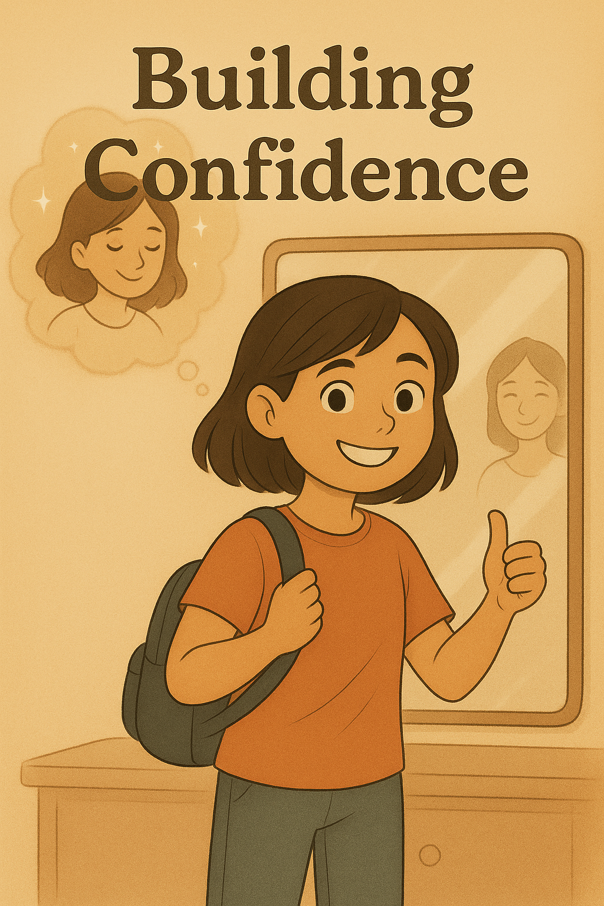
Allegra’s kind words still danced in Iris’s ears. They were like sparkles lighting up the dark.
With a new bounce in her step, Iris hopped out of bed. She twirled once, then zipped down the stairs, her heart feeling a little lighter.
She brushed her hair, tied her shoes, and put on her biggest, bravest smile.
“This isn’t a big deal,” she told herself in the mirror. “I can totally do this!”
Up in the sky, floating gently like a soft cloud, Allegra watched with pride.
“You’ve got this,” she whispered with a warm, sparkly smile. “I believe in you.”
When Iris stepped into her homeroom class, the room suddenly felt very quiet. A sea of curious eyes turned to look at her. Iris gulped.
Whoops. This is harder than I thought, she whispered to herself.
Just then, Allegra appeared by her side with a gentle smile.
“Take deep breaths,” she said kindly. “Close your eyes. Inhale through your nose… hold it for five seconds… then exhale out through your mouth.”
Iris nodded, her shoulders still a little tense.
“Let’s do it together,” Allegra said.
They stood still and breathed slowly.
“In through your nose… hold it… and out through your mouth. Nice and slow, just like that.”
Iris felt her chest rise and fall. After a few breaths, the butterflies in her belly didn’t feel so fluttery anymore.
She walked to her desk—and to her surprise, the girl sitting next to her was a friend from last year!
Their eyes lit up, and they started talking right away, giggling about their summer vacations and all the ice cream they’d eaten.
Allegra gave her a proud thumbs-up. “See? That wasn’t so hard. You’ve got this!”
“Yeah,” Iris said, smiling wide. “It actually seems easy now.”
Her friend turned to her with a grin. “Wow, Iris! You’ve gotten so much more confident this year!”
Iris felt her cheeks warm, but this time, it wasn’t from nerves.
It was pride.

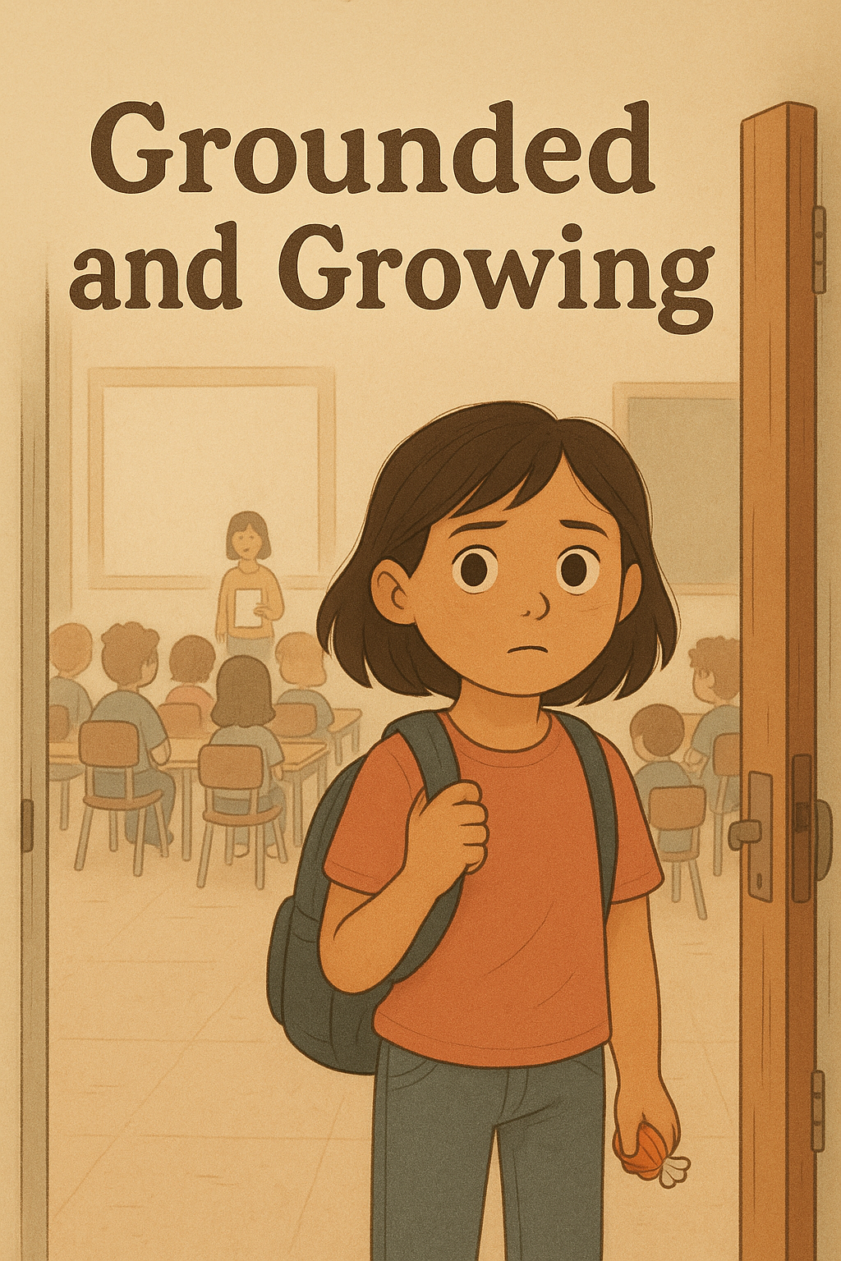
The bell rang, and Iris walked to her next class.
Her smile faded.
She stood at the doorway, staring at a room full of strangers.
Her heart thudded in her chest—fast and loud. It always did that when she felt nervous.
Suddenly, Allegra appeared by her side and leaned in with a soft whisper.
“I know you’re nervous because you don’t know anyone in here. But that’s okay. We can do a grounding exercise. It helps bring you back to the present moment.”
Iris tilted her head. “What’s a grounding exercise?”
“It’s a mindfulness trick,” Allegra explained with a smile. “I’ll ask you something, and you answer. Ready?”
Iris nodded, still unsure but curious.
“First,” Allegra said, “tell me five things you can see.”
Iris glanced around the unfamiliar classroom.
“I…I see the whiteboard,” she whispered. “I see the teacher. I see desks and chairs. I see my hands…they’re sweaty. And I see a bunch of kids I don’t know.”
“Perfect!” Allegra cheered softly. “Now, four things you can feel.”
Iris thought for a moment.
“I feel my heart racing in my chest. I feel my face getting warm because I’m shy. I feel a chill from the air conditioner. And…I feel safe because you’re with me, Allegra.”
Allegra beamed. “See? You’re doing great. Now, what are three things you can hear?”
Iris closed her eyes. “I hear kids talking…I hear the teacher calling names…and I hear myself telling you what I hear.”
“Nice!” said Allegra. “Okay—two things you can smell?”
Iris smiled. “I smell the teacher’s lavender perfume…and the flowers you always smell like.”
Allegra giggled. “Last one! One thing you can taste.”
Iris reached into her pocket and pulled out a chewy candy wrapped in shiny foil. She popped it into her mouth.
“I can taste my favorite chocolate-vanilla taffy,” she said, smiling. “My mom gave it to me this morning—for good luck.”
Allegra nodded. “And now that you’re grounded, go on—introduce yourself.”
Iris took a deep breath.
Warmth bloomed in her chest.
She stepped forward, ready.
“Hi,” she said, voice steady. “I’m Iris.”

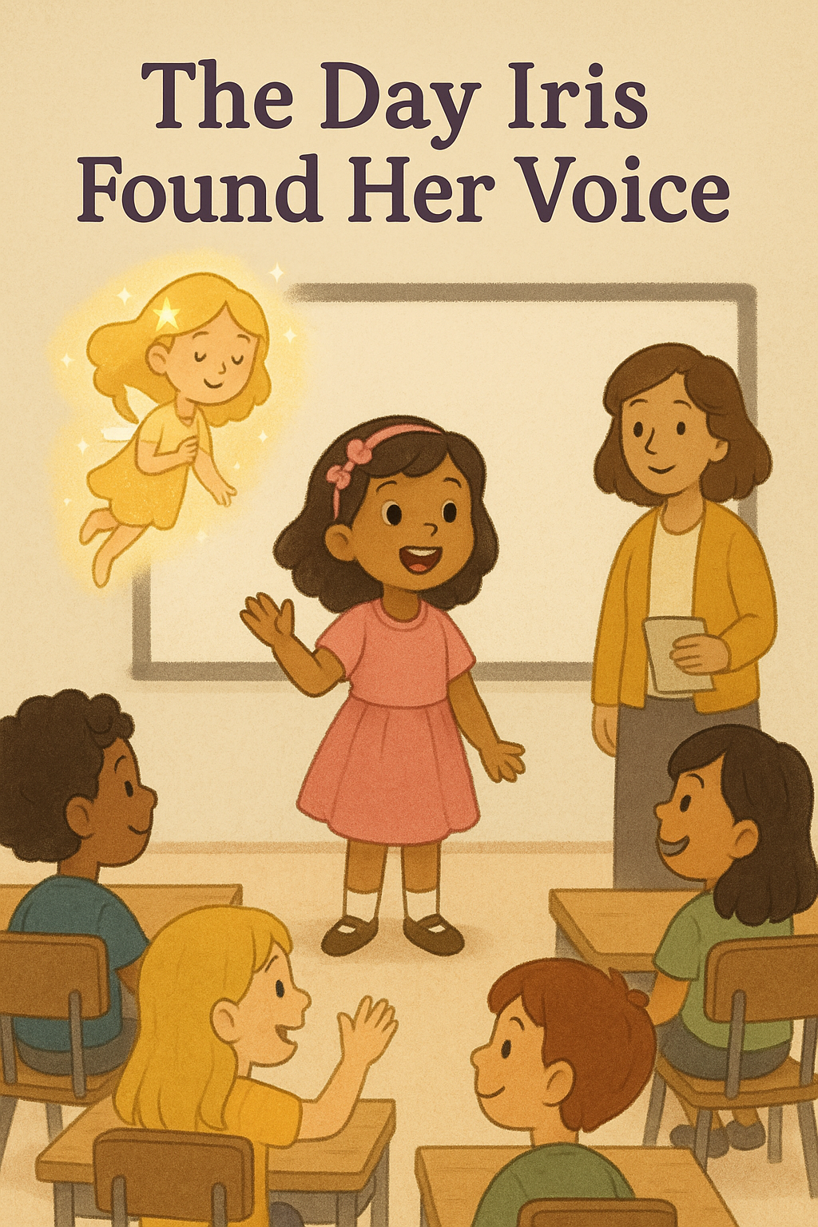
Iris walked to the front of the classroom, her heart thumping—but steady. She took a deep breath, just like Allegra had taught her, and looked out at the sea of faces.
With a bright, confident voice, she said, “Hi! My name is Iris! I’m six years old, and I love the color pink! I play the violin and the flute, and I love singing! I hope I can get to know each one of you!”
There was a pause—and then the whole class smiled and called out together, “Welcome, Iris! We want to get to know you, too!”
Allegra appeared beside her with a proud grin. “See? What did I tell you?”
Iris beamed as she walked back to her seat, her steps light with pride.
A girl nearby waved and said, “I love the color pink, too! Nice to meet you!”
Iris smiled back, her nervousness melting away.
She felt so much better—and grateful. Grateful for Allegra, and for the calming strategies she had learned.
And from that day on, whenever her heart fluttered with doubt or nerves, Iris remembered to breathe deeply, whisper kind words to herself, and ground her thoughts.
It always helped.
Because now, she knew her voice—and she knew it mattered.

